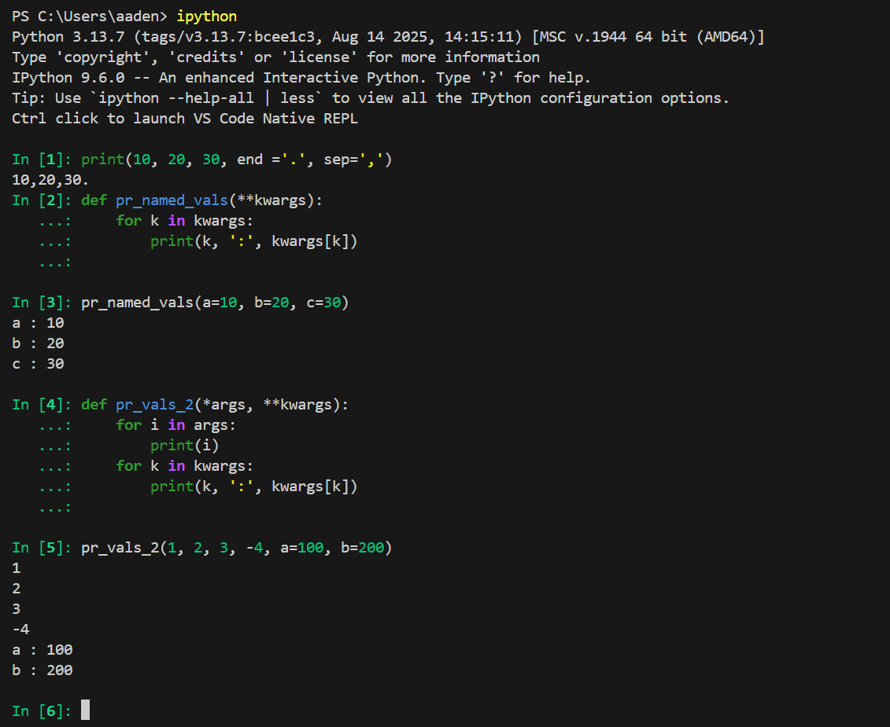

Advantages of \*\*kwargs:

1. You can pass as many named arguments as you want.
2. Makes the function readable and more specific (has names) compared to \*args.
3. Easy to add more parameters.

Disadvantages of \*\*kwargs:

1. Can be hard to debug.
2. There is no structure, so if I misspell a name for an argument it will be incorrect but there will be no error, creating a separate misspelled key.
3. Code can be messy if \*\*kwargs is overused.